

| Business Template  **Advanced Reporting Concepts** |
| --- |
|  |

## PART A: Creating Simple DAX Expressions

Power BI allows you to quickly transform data into insights and take action. However, ensuring that the data in your Power BI reports and dashboards is up to date is essential. Knowing how to refresh your data is critical for delivering accurate results.

Within Power BI Desktop, you can define roles and set rules for data access. In the Power BI Service, you can add members to these roles by entering the email address or name of the user, security group, or distribution list you want to include.

Note that you cannot add groups created within Power BI itself.

## PART B: Creating Simple DAX Expressions

In Power BI Desktop, you can use bookmarks, buttons, and selection features to make your reports more engaging, interactive, and easier for users to navigate.

**Bookmarks** capture the current configured view of a report page, allowing you to quickly return to that exact view later. Bookmarks can serve multiple purposes: they help you keep track of your progress while building reports, and they can also be used to create PowerPoint-like presentations that navigate through bookmarks in sequence, effectively telling a story with your report.

**Selections** let you control which items in the report are visible or hidden. Selections work hand-in-hand with bookmarks and buttons to enhance interactivity and user experience.

## PART C: Using Buttopns To IMprove User Experience

You can use bookmarks, buttons, and selections in Power BI Desktop to make your reports more compelling, interactive, and easier for users to navigate.

**Buttons** enhance the interactivity of your reports by allowing users to engage more dynamically with the content. When you add buttons with assigned actions, your report behaves more like an app—users can hover over, select, and interact with elements seamlessly.

The available button action types include:

* Back
* Bookmark
* Drill through
* Page navigation
* Web URL

## PART D: Creating Tooltips Based On Report Pages

You can create visually rich report tooltips that appear when you hover over visuals, using report pages you design in Power BI Desktop. By building a dedicated report page as your tooltip, you can customize it to include visuals, images, and a variety of other elements you add to the page.

This opens up many creative possibilities to enhance your report tooltips and make them more informative and engaging.

## PART E: Field Parameters

Field parameters enable users to dynamically switch between different measures or dimensions within a report. This feature empowers report viewers to explore and customize the analysis by selecting the specific measures or dimensions they want to focus on.

## PART F: Decomposition Tree

The decomposition tree visual in Power BI allows you to visualize data across multiple dimensions. It automatically aggregates data and lets you drill down into dimensions in any order you choose.

Additionally, as an AI-powered visualization, it can suggest the next dimension to explore based on specific criteria. This makes the decomposition tree especially valuable for ad hoc data exploration and root cause analysis.

## PART G: Conditional Formatting

Conditional formatting lets you customize cell colors—including gradients—based on field values. You can also use it to represent cell values with data bars, KPI icons, or active web links. This feature helps draw attention to or highlight important data in both text and numeric fields using colors, icons, or data bars.

## PART H: Parameters For Data Source

Parameters in Power Query provide a flexible way to dynamically change values during the Get Data and Transform process. They allow you to adjust values without opening the Power Query Editor in Power BI Desktop.

Parameters are also useful in the Power BI Service, enabling you to manually update values without needing to open the PBIX file in Desktop and republish it.

## PART G: Lab Report

First, I configured Row-Level Security (RLS) by accessing the **Managing Roles** option in the toolbar and selecting **Create New Role**. For each role, I assigned access to the same table but filtered by a different value. The main goal was to assign each group—such as Australia, Canada, France, Germany, United Kingdom, and United States—access only to customer data for their specific country or region.

This was achieved using the **DimGeography** dimension table, which has a one-to-many relationship with the **DimCustomers** table. Based on the group a viewer belongs to, they can only see customers born in that respective region. This setup reflects a typical company structure where different teams are responsible for different markets, such as Germany, France, or the United States. It ensures that each team, with their specialized expertise in their market, only accesses relevant data for their area.

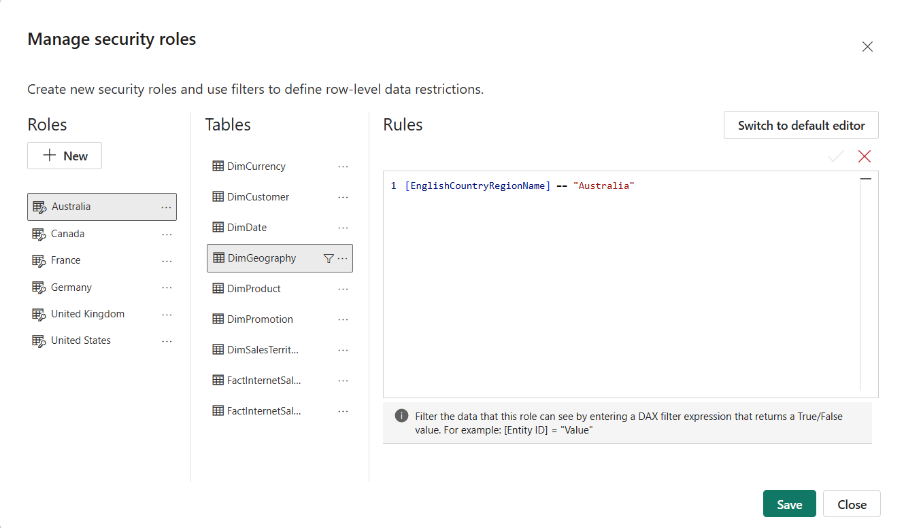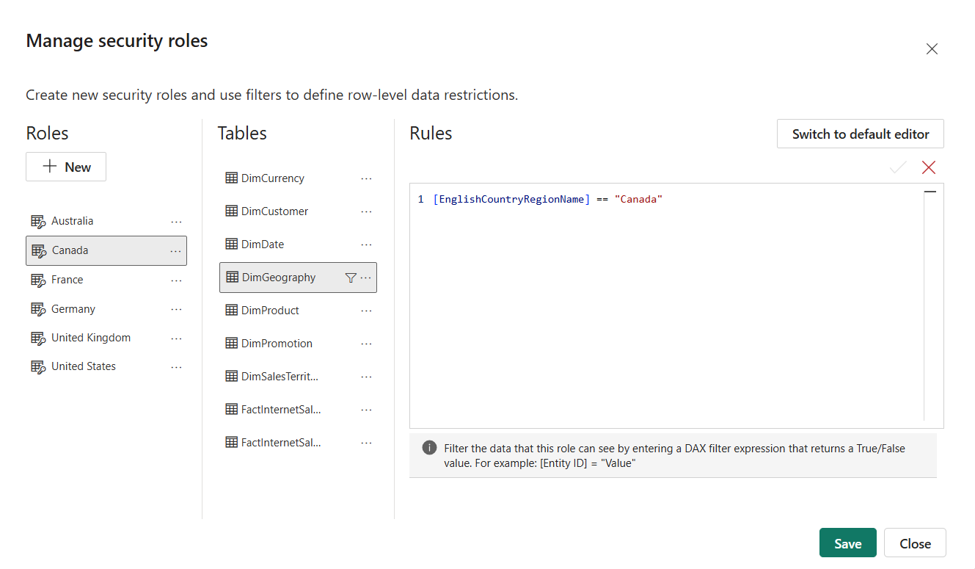

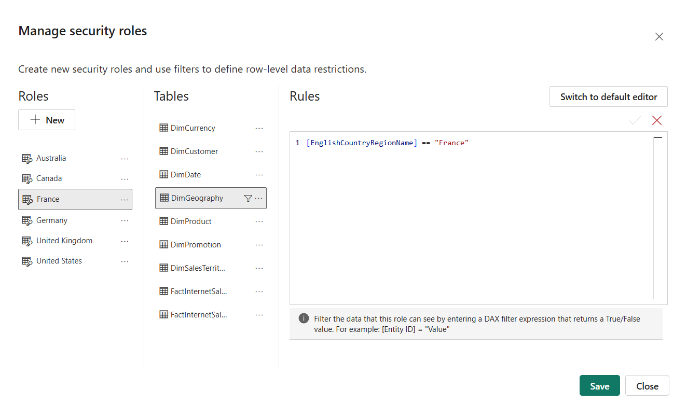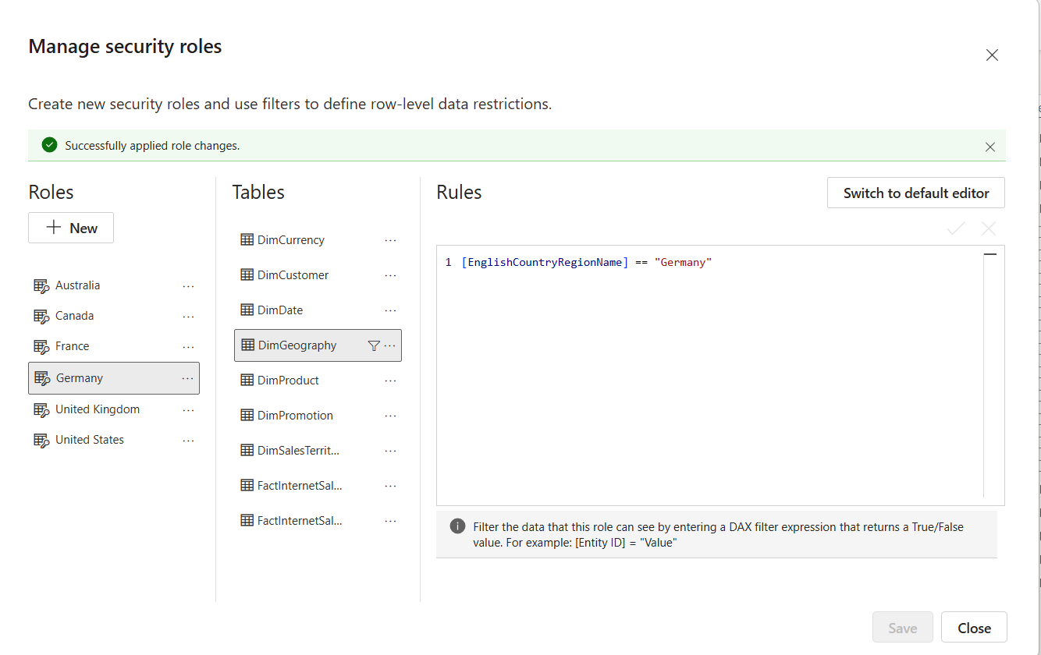

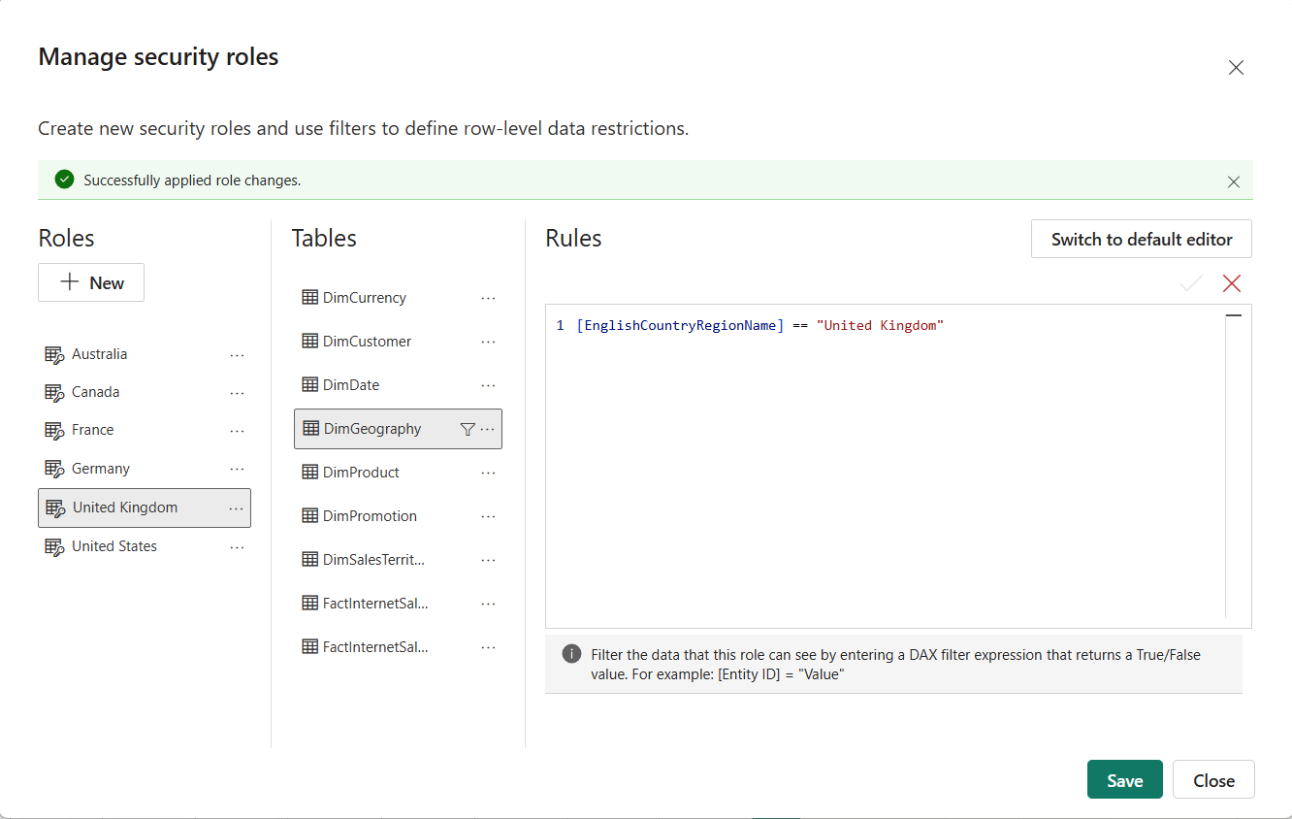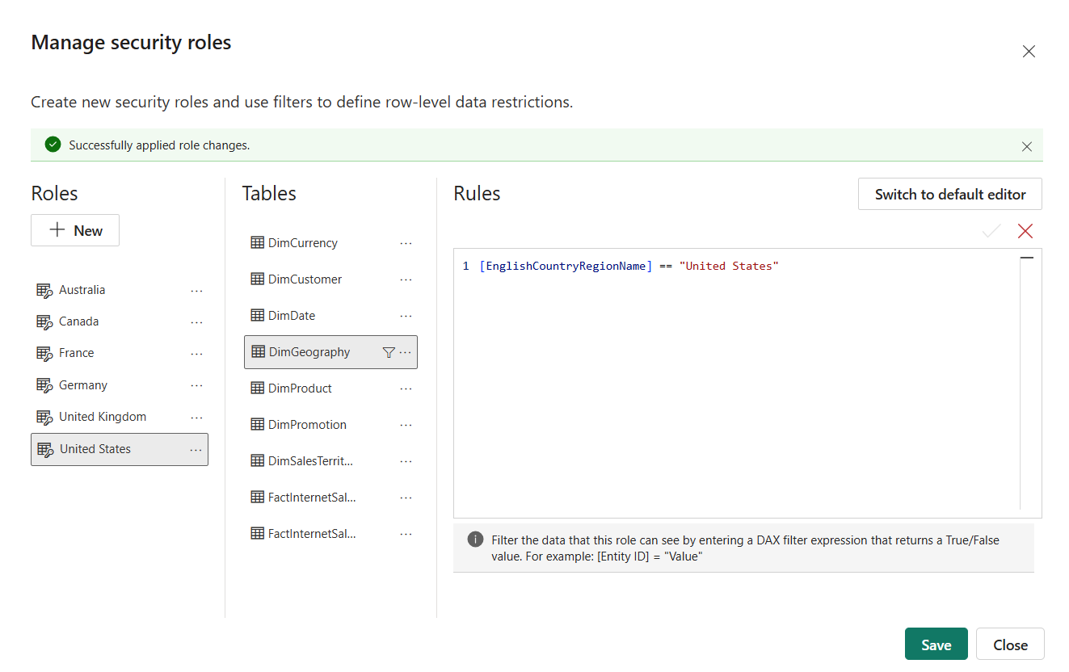

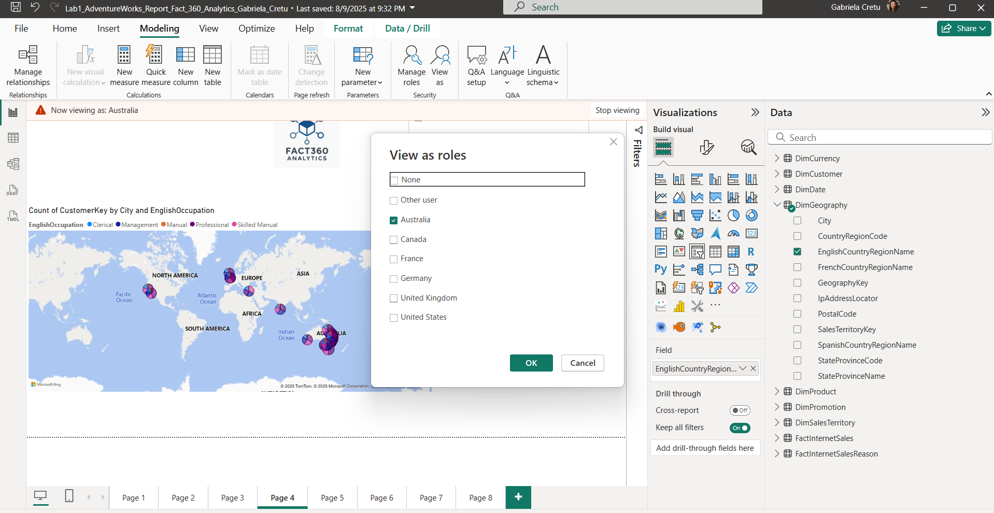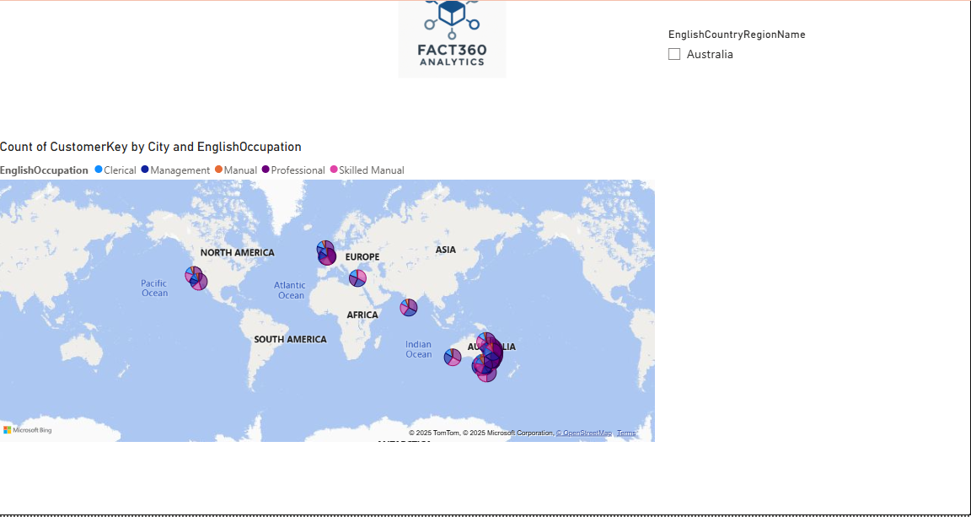

Next, I explored the option of implementing dynamic RLS. To do this, I created a table called **Dynamic RLS** with two columns: **Reporter** and **Country Region**. I linked this table to the **DimGeography** table via a one-to-many relationship, enabling the definition of a dynamic row-level security rule based on the USERPRINCIPALNAME() function.

Essentially, this setup means that if the logged-in user’s username matches the **Reporter** in the **Dynamic RLS** table, they will only see sales data for the country region assigned to them. If the username is not found in the table, the rule restricts access so that no data is displayed.

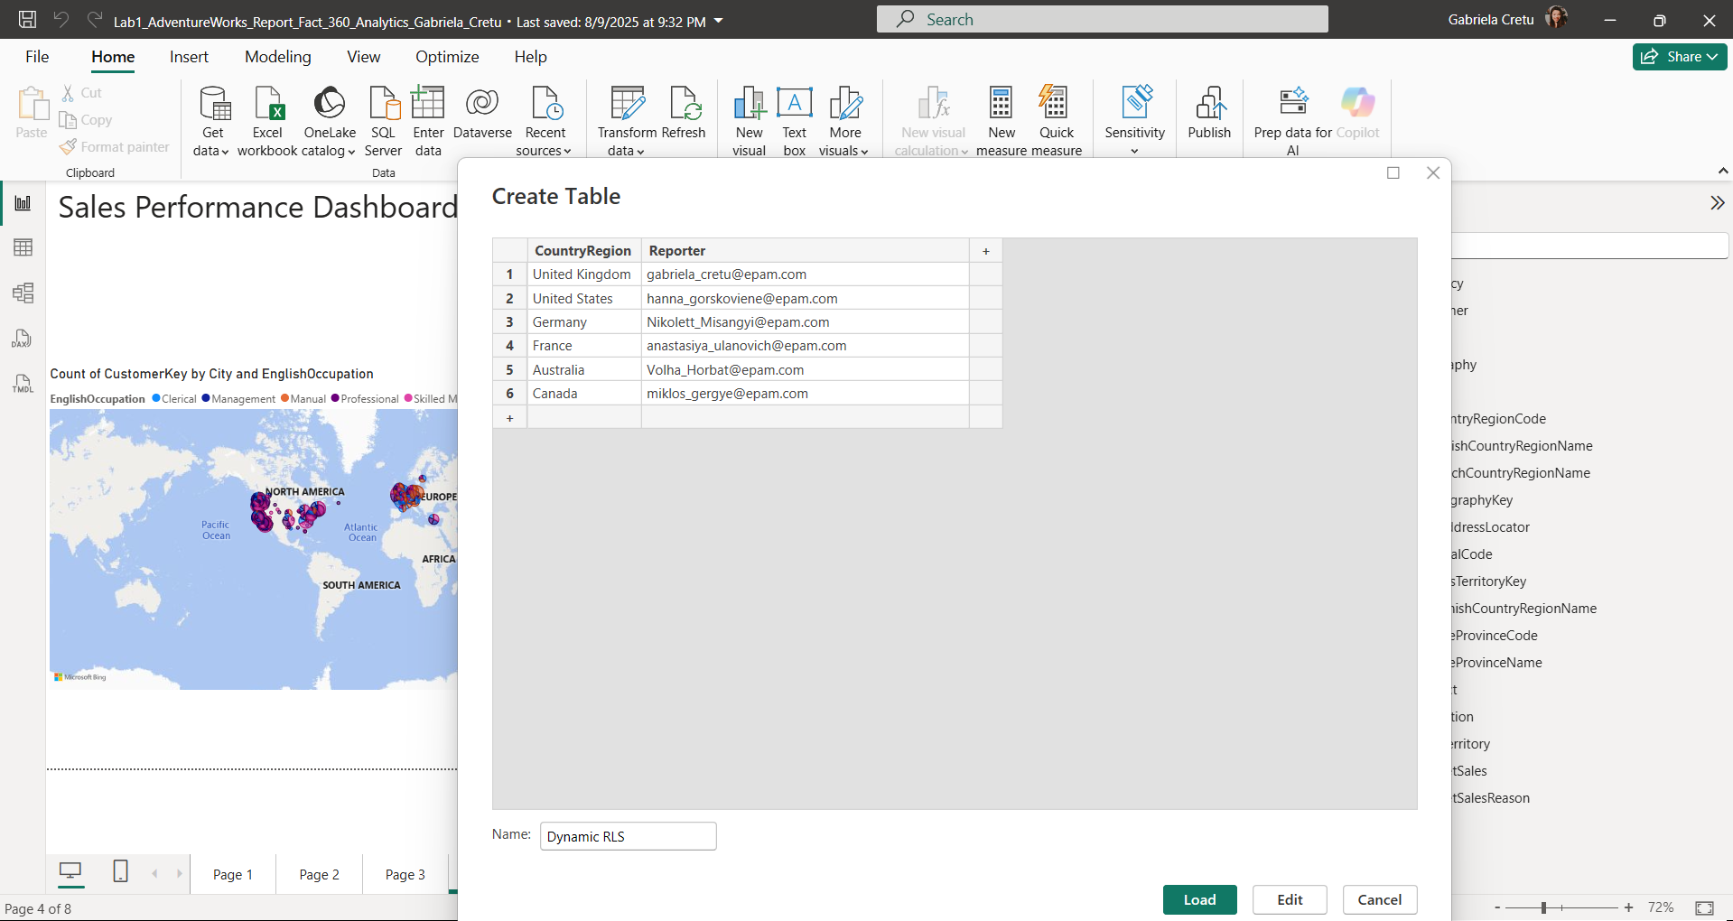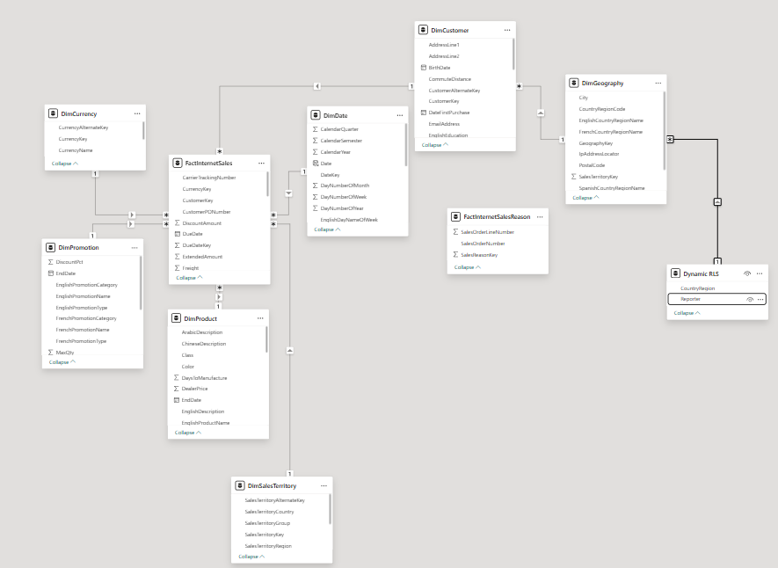

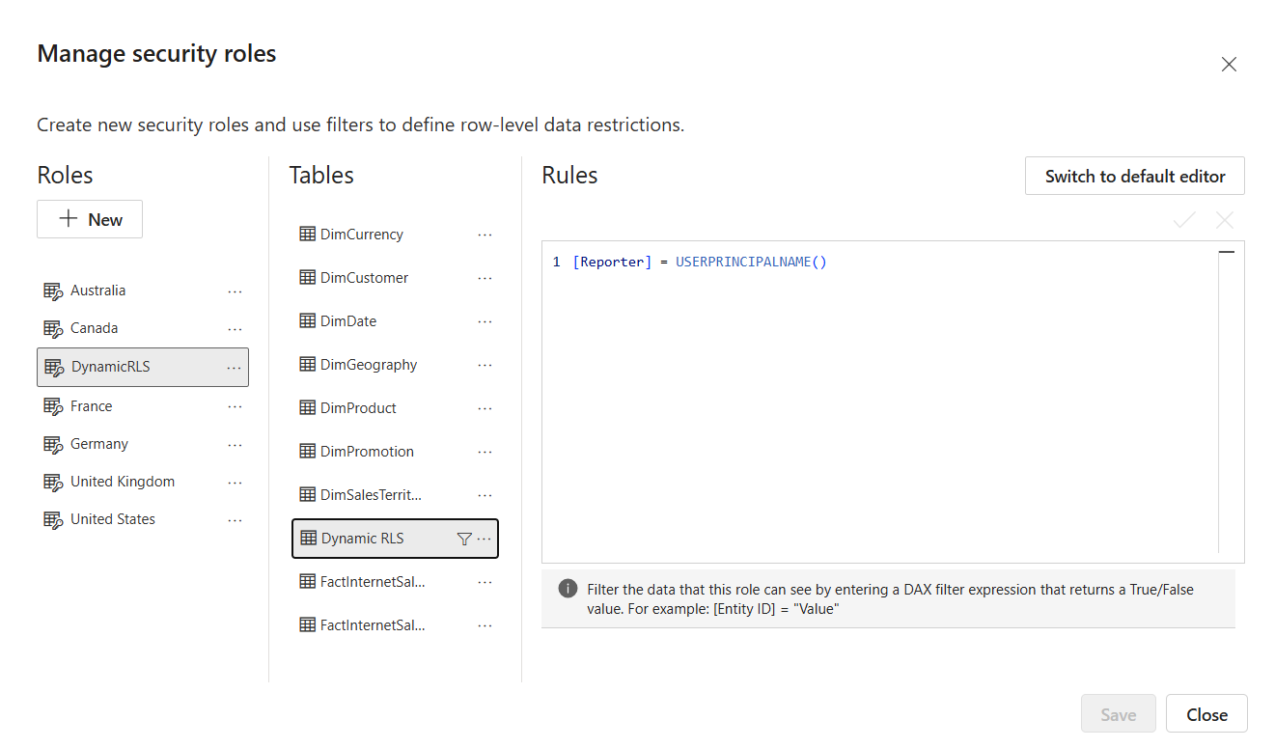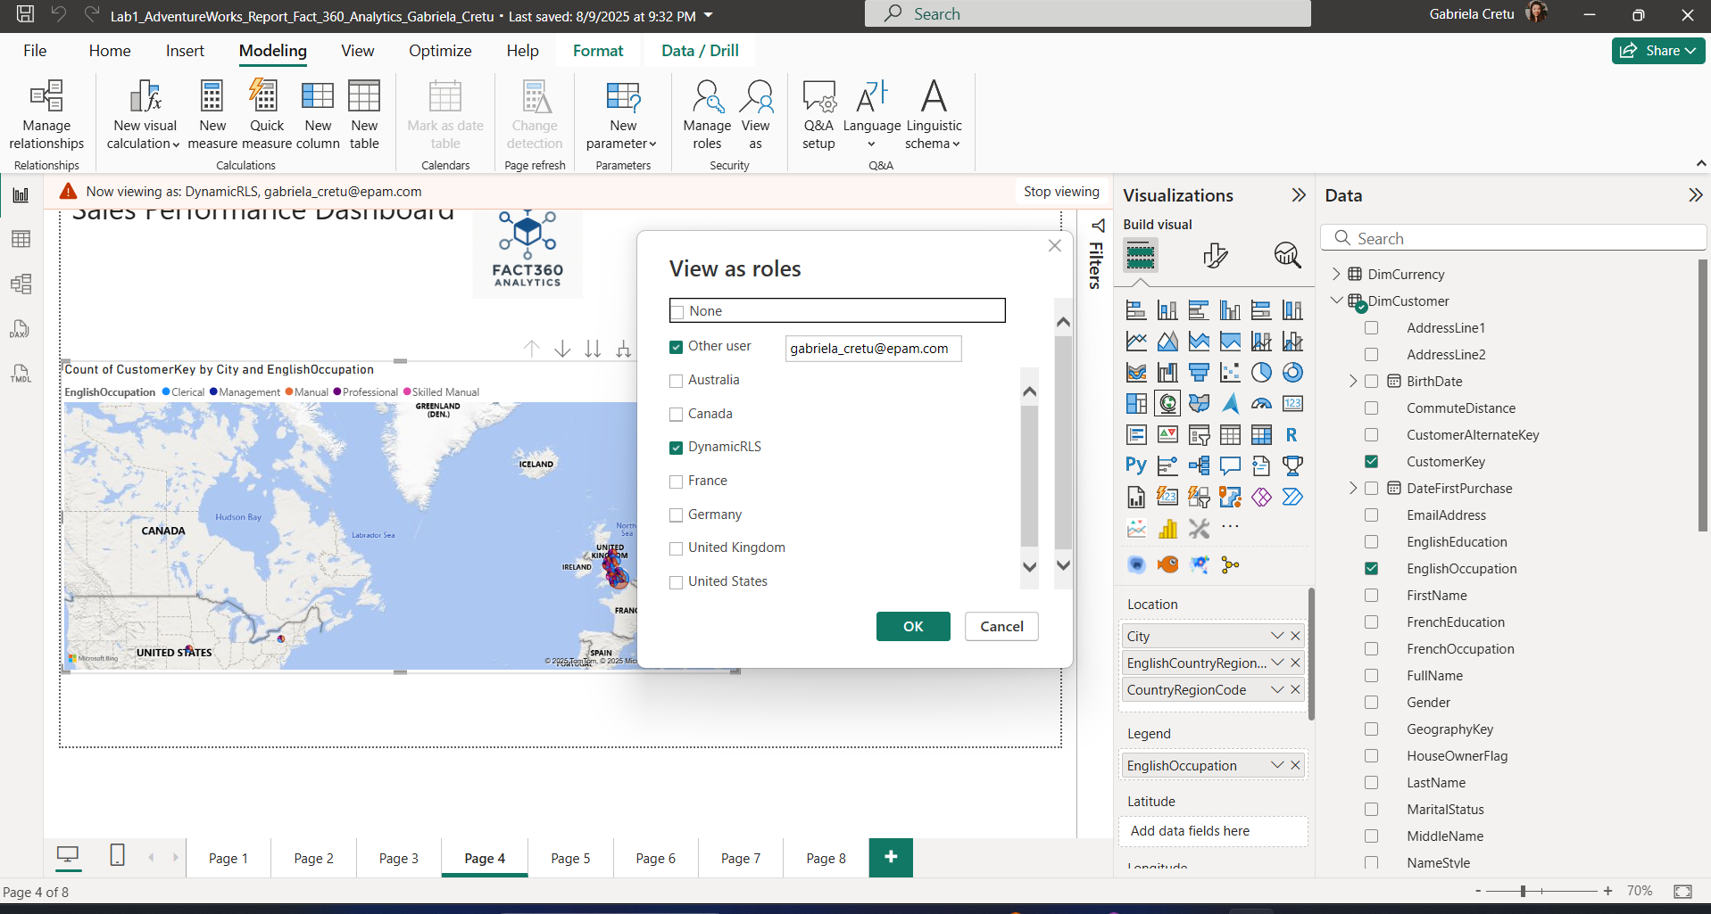

Afterwards, I applied a similar approach—but this time not dynamic—directly in the Power BI online service. Using the previously defined table, I assigned reporters to specific groups (such as Australia, Canada, France, etc.) through their EPAM accounts. For example, the user **Volha_Horbat@epam.com** was assigned to the Australia group. When viewing the report as Volha, only data for Australia appears in the slicer on the far right. Additionally, both the Australia role and Volha’s role show the same values on the map, ensuring consistent data visibility.

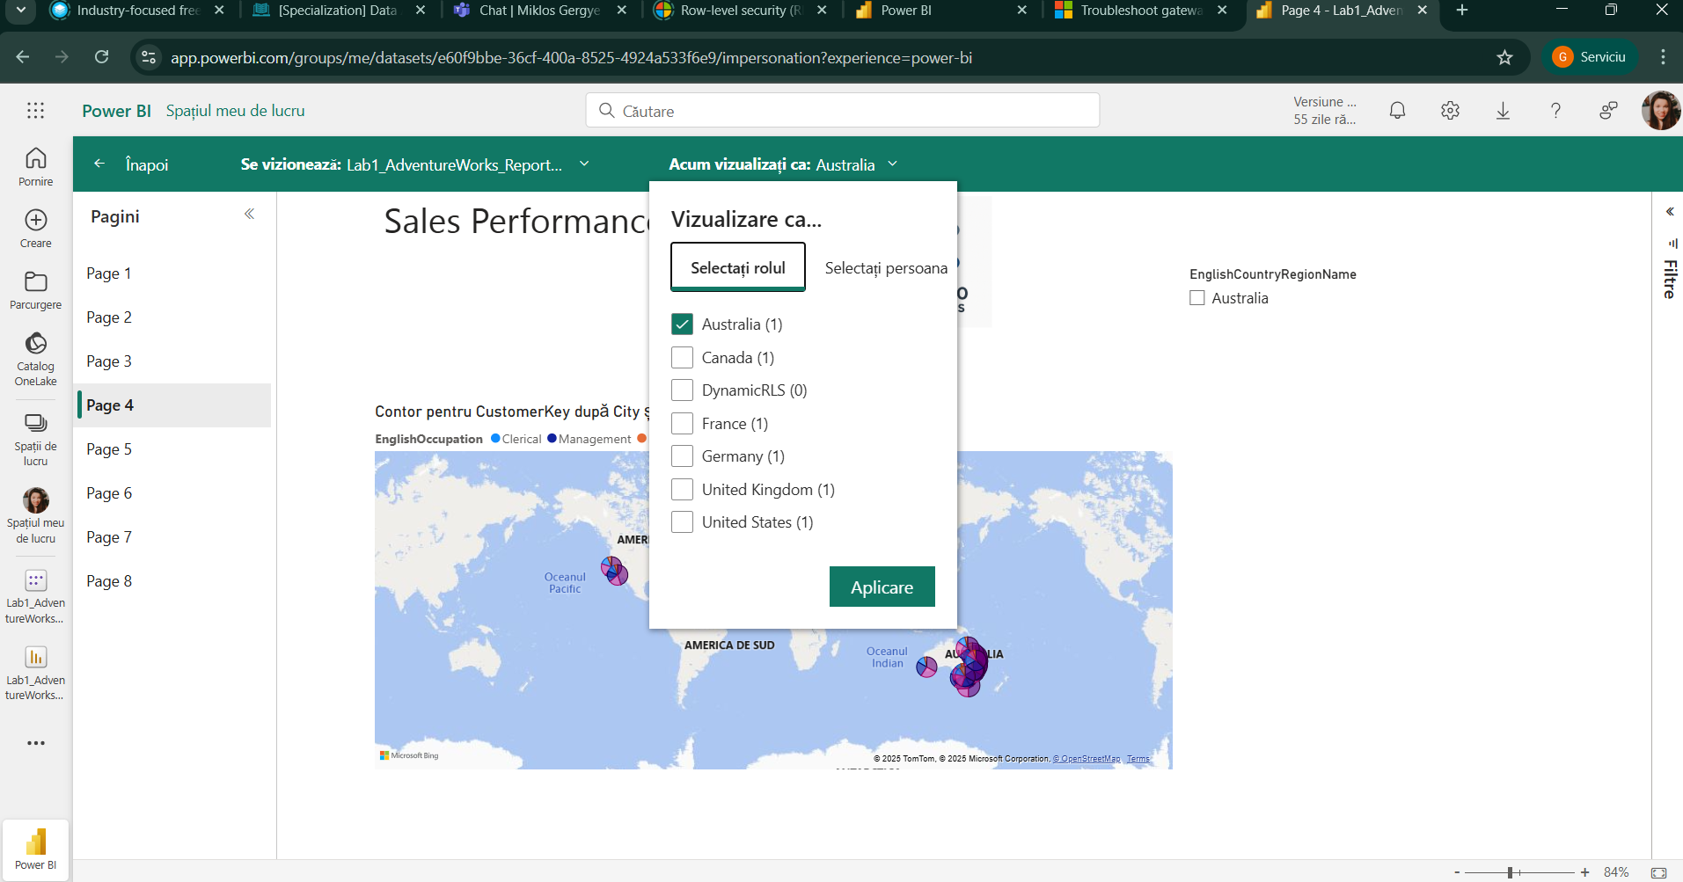

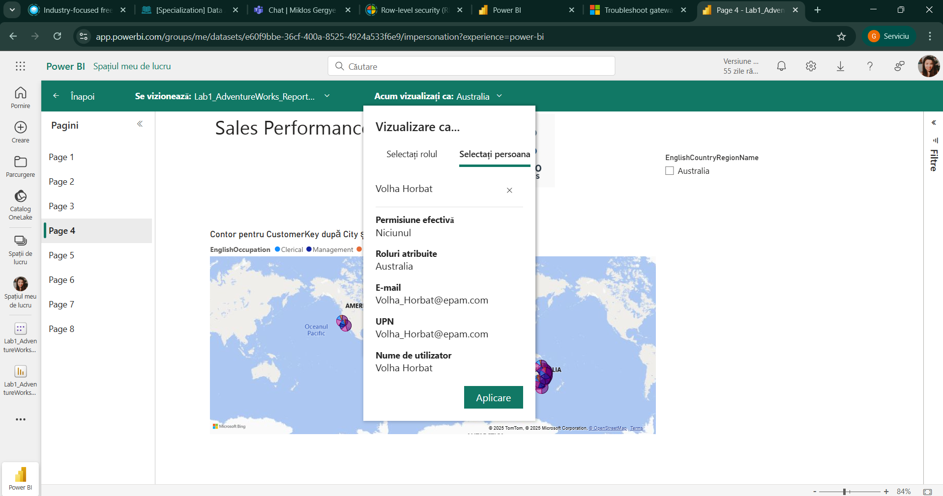

Next, we used Power BI’s button functionality to switch between bookmarks on the same page. I created two bookmarks: the first one displays the customer occupation map, while the sales amount binning visualization is hidden. For the second bookmark, the map is hidden, and the sales amount binning visualization is shown instead.

Finally, we added two buttons that are always visible. The first button switches to the bookmark showing the global distribution of customer occupations, and the second button switches to the bookmark displaying the binning of transaction amounts spent by each customer.

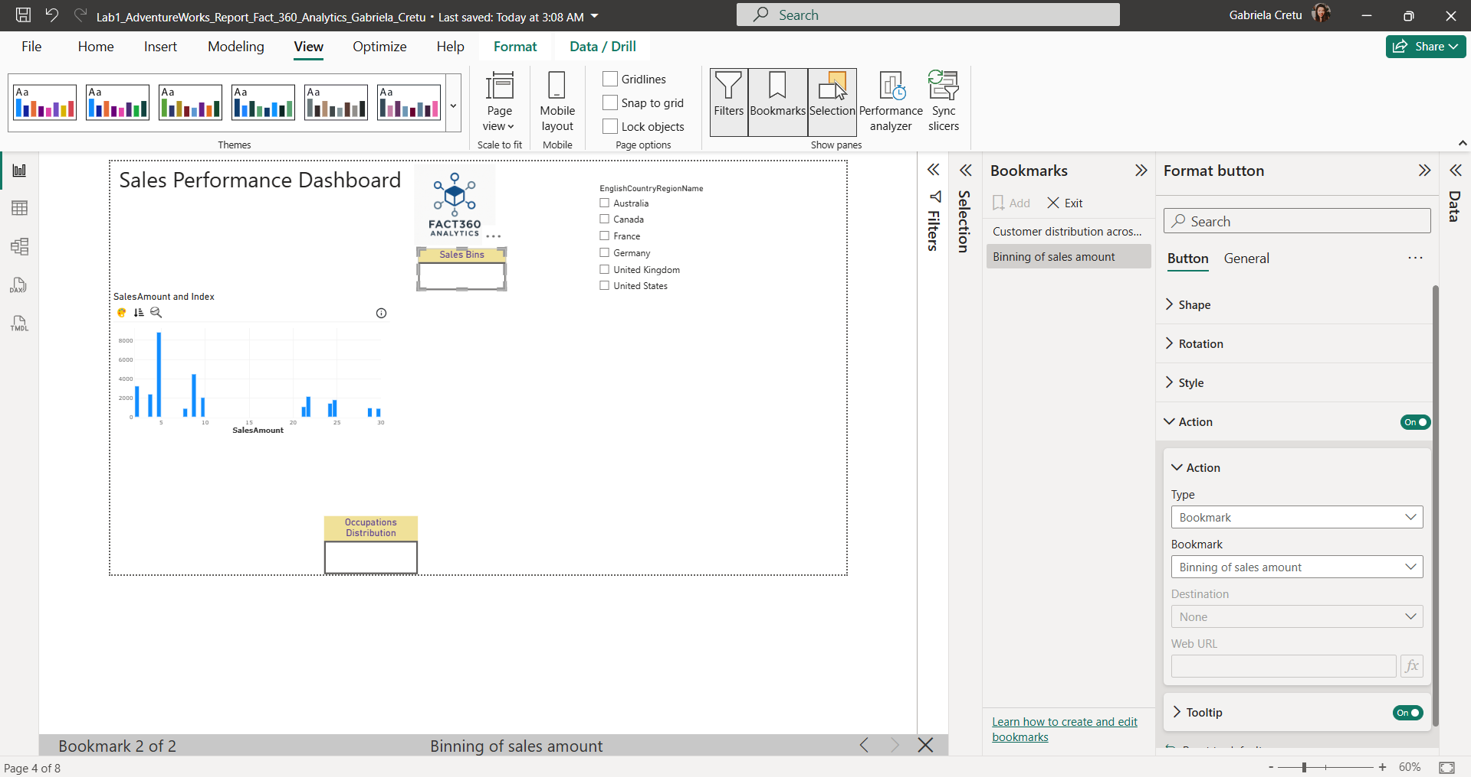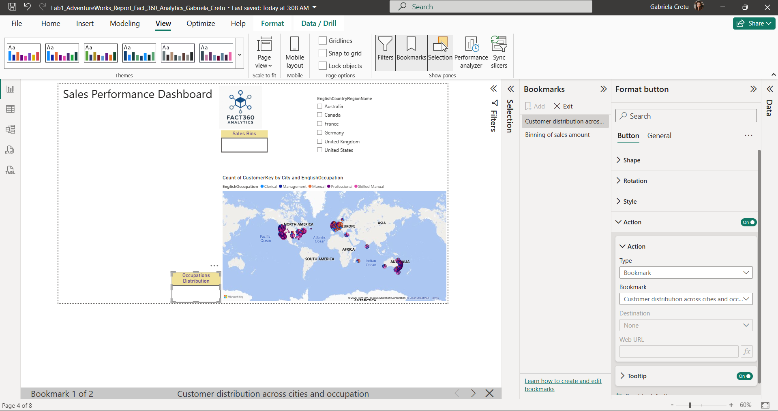

Since we recognized that in real-world scenarios it’s often important to analyze cumulative sales on a monthly or quarterly basis—not just yearly—we added a switching option for different time periods. To achieve this, we created a disconnected table listing the cumulative sales frequencies: MTD (Month-To-Date), QTD (Quarter-To-Date), and YTD (Year-To-Date).

Using this table, we created a slicer (shown in the screenshot) that controls the underlying data table. To make the slicer functional, we replaced the previous YTD cumulative sales column with a new measure called **Order Quantity Selected Period**. This measure uses a variable to capture the selected period from the slicer (defaulting to YTD if nothing is selected) and then employs a SWITCH statement to return the appropriate cumulative sales value—whether MTD, QTD, or YTD—based on the user’s selection.

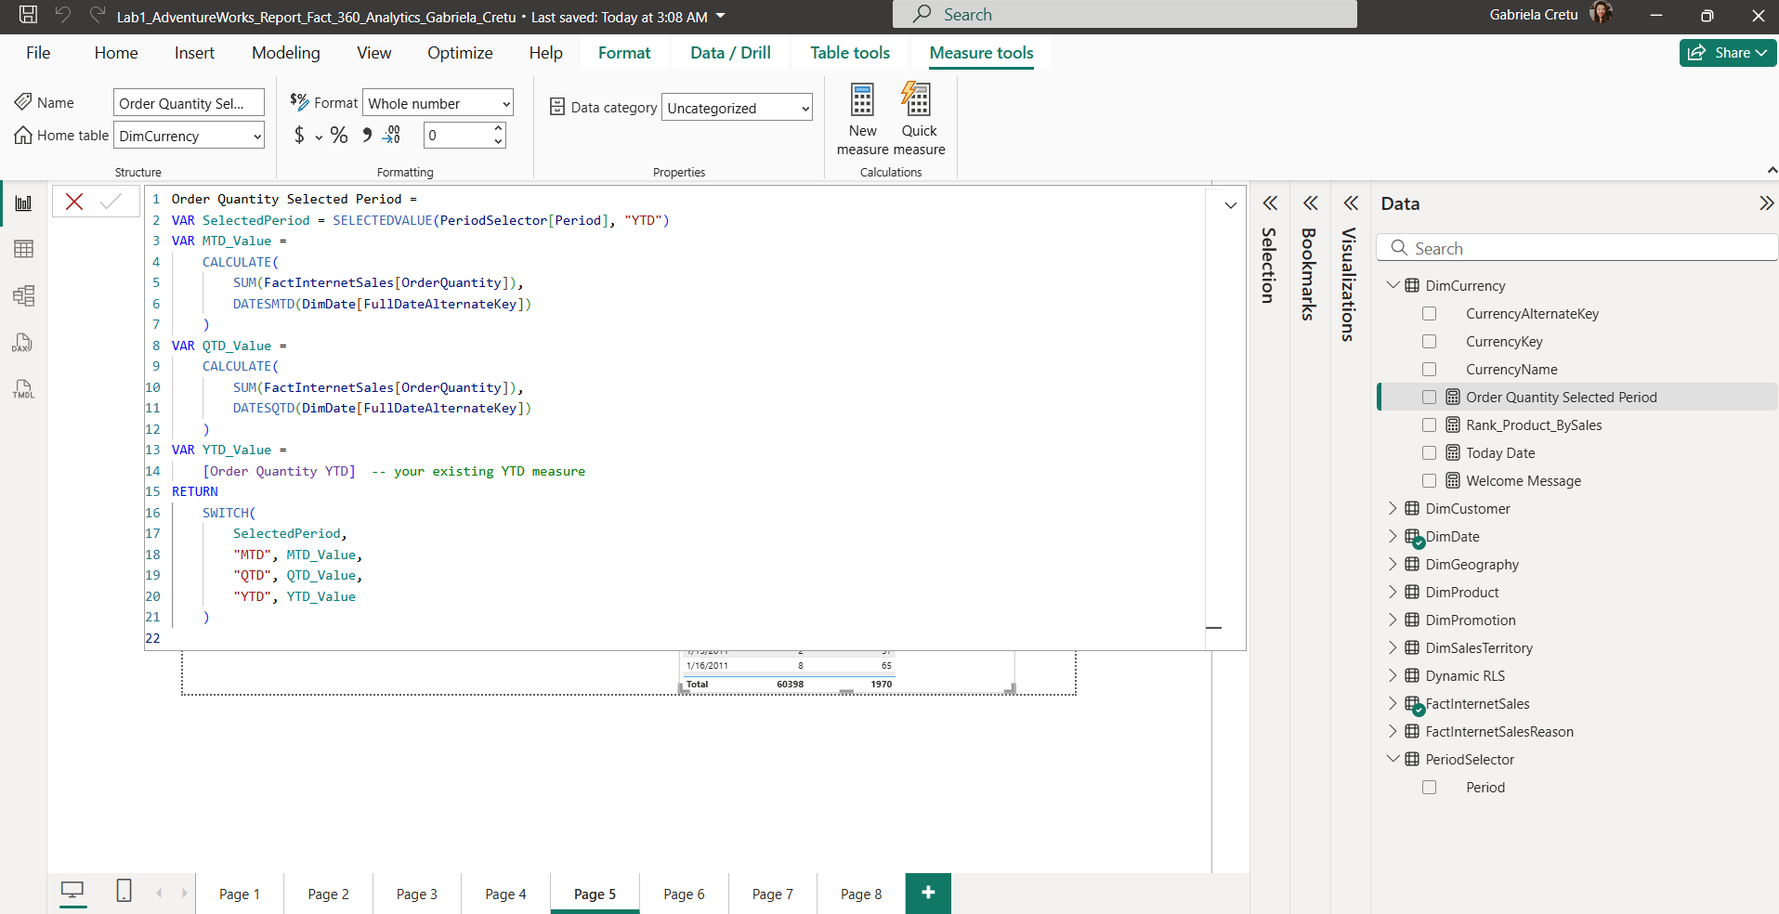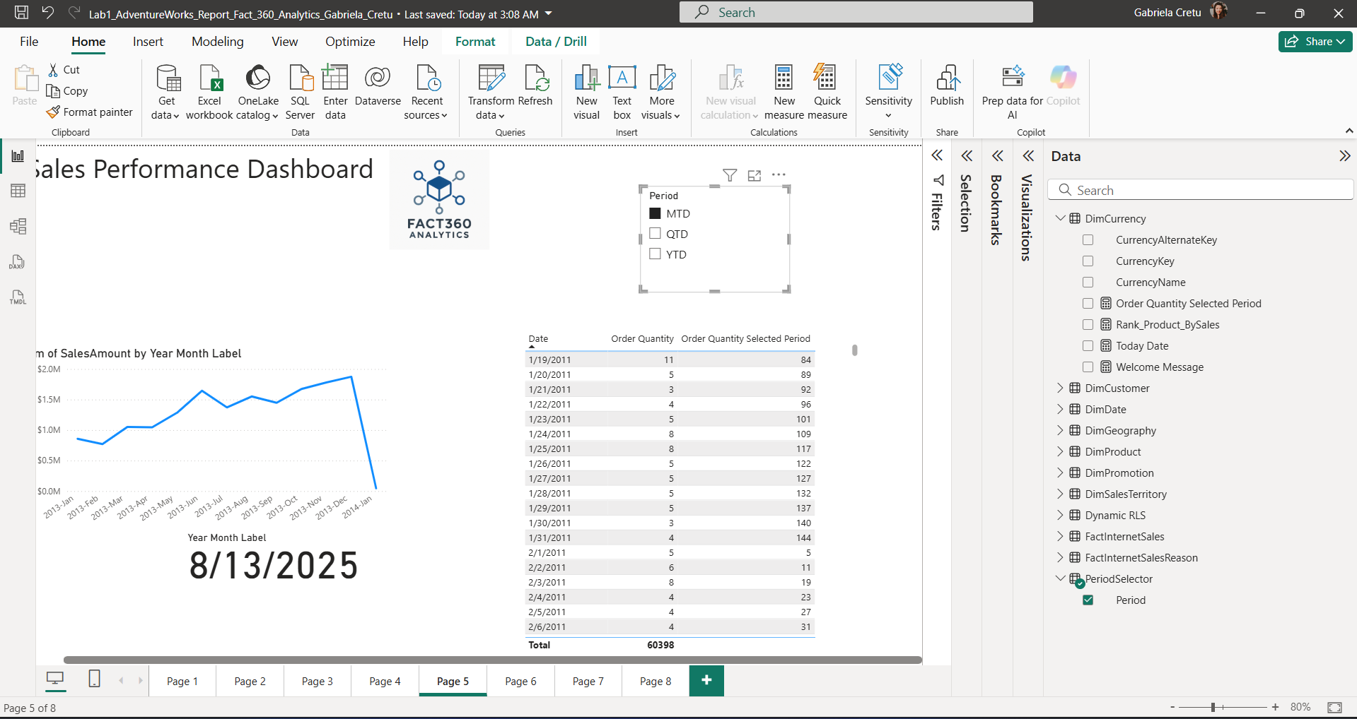

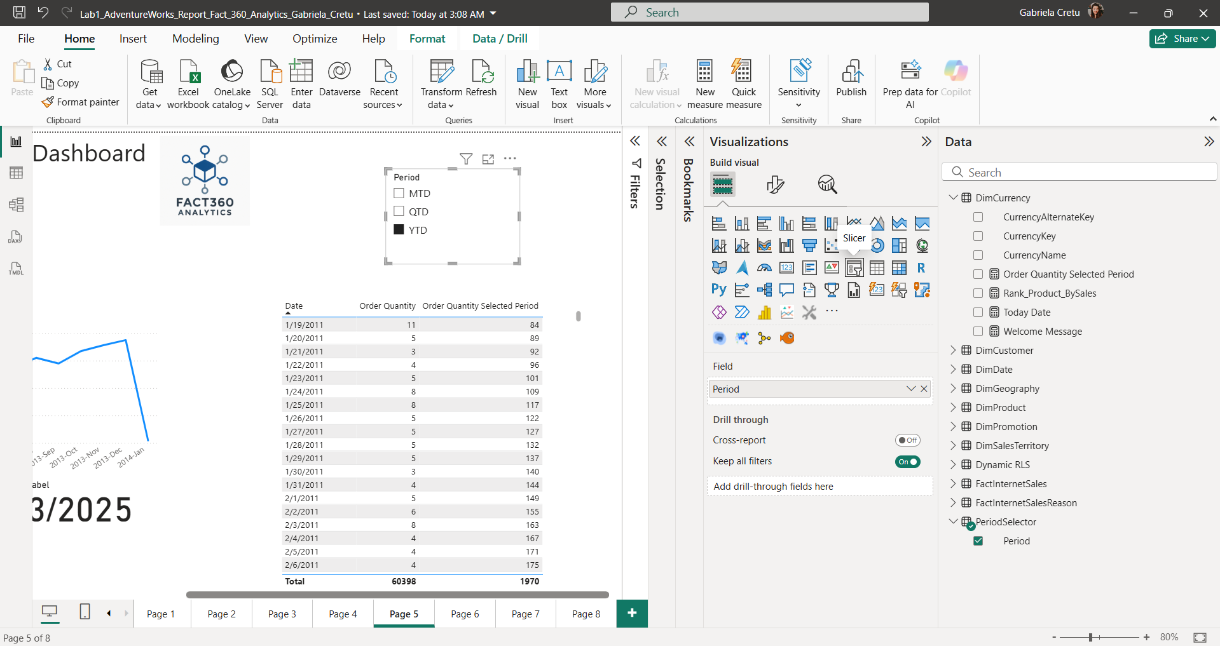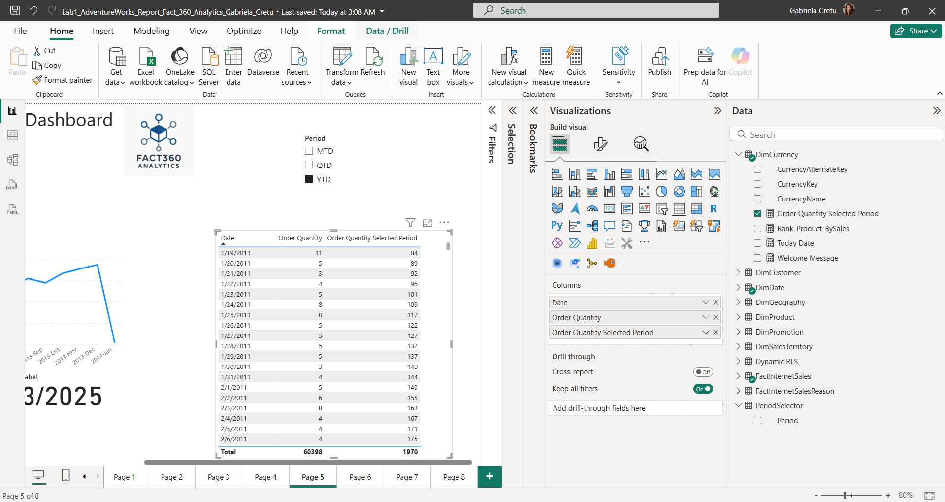

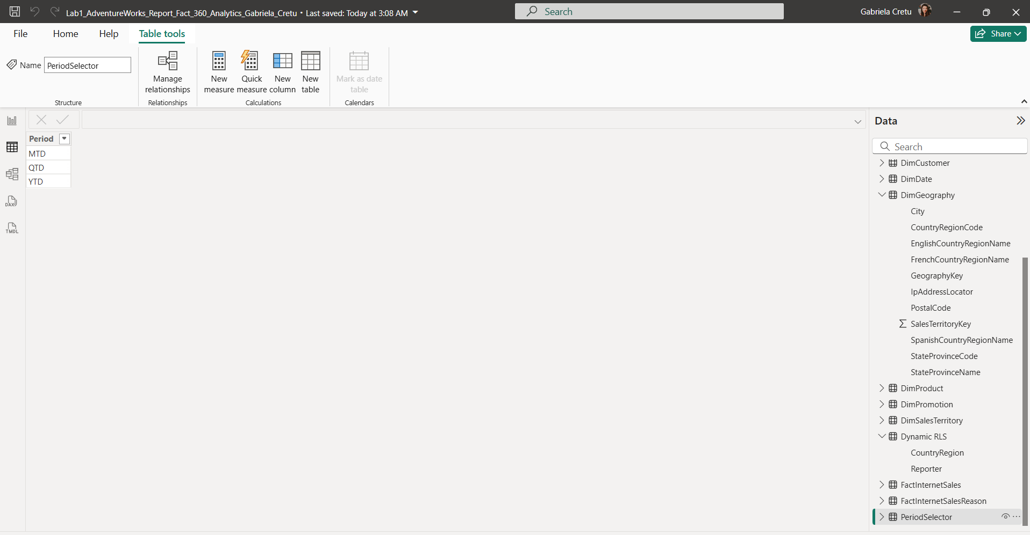

To gain a deeper understanding of the sales data, we used a decomposition tree for analysis. We began with **sales quantity measured per day** as our starting point. From there, we broke down the data using three key independent variables in sequence: **Year → Country → Class of Product**.

Through this approach, we observed that **2014 had the highest overall sales quantity**, with the **USA contributing the most** within that year. When further drilling down into the **Class** of products, we noticed that class information was largely missing across most countries. This significant lack of data suggests that the **Class attribute may not be a reliable or relevant metric** for characterizing the quantities purchased in this dataset.

This decomposition tree allowed us to isolate important trends and identify where data quality or completeness might impact the analysis.

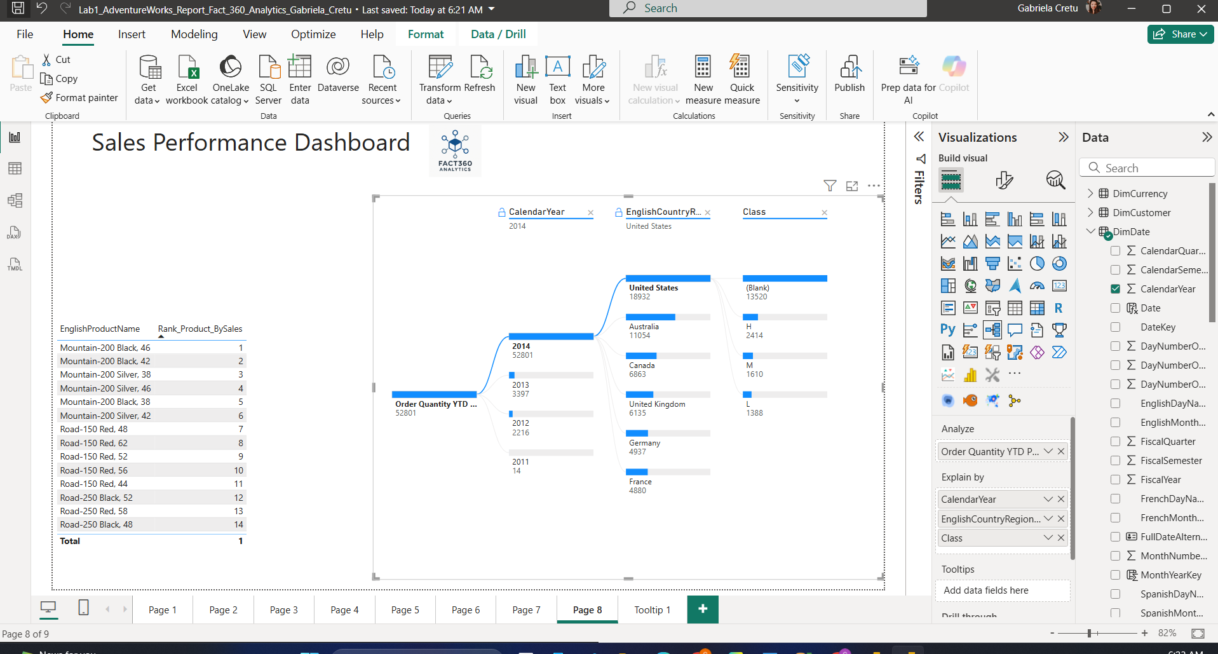

Finally, we implemented a tooltip to create a hover effect when the cursor is placed over small KPI cards, such as those displaying the max order date and sales amount max order date in this grouped set of visualizations. This is considered good practice because it provides additional context and detailed information without cluttering the main report view, enhancing the user experience by making key insights easily accessible on demand.

